Coconuts and Islanders

**A)** There are N = 300 inhabitants (natives, castaways, etc.) on the island, initially each receives C = 15 coconuts. The inhabitants play a game of   
paper-scissors-stone, the loser in a pair passes 1 coconut to the other person   
(if they have one). Pairs are chosen at random.

Perform a simulation of T = 100000 games and plot a histogram (probability density) as a function of the number of coconuts owned. Mark on the histogram the function (approximation of the distribution for N, C >> 1)   
p(x) = 1/(1+C) ∗ e−x/kT , where kT = C + 0.5.

**B)** Plot the number of people with zero coconuts as a function of the number of games (e.g., every 1000 games). Plot with a dashed line the value of p(0) ∗ N.

All graphs should have a title, axis description, grid and be saved to a file.

An example solution to a similar problem can be found in *“Coconuts and Islanders: A Statistics-First Guide to the Boltzmann Distribution”* by Brian Zhang; <https://doi.org/10.48550/arXiv.1904.04669>  
For extra hints see below.  
Example solution graphs are shown in Figure 1.

Hints on writing code:

N = 300; C = 15

x = np.ones(N) * C

I, j = np.random.choice(N, 2)

…

x[i] += -1

…

plt.hist(x, bins='auto', density=True, alpha=0.75)

plt.plot(xarr, yarr)

p = np.random.rand() # *single random value*

p_arr = np.random.rand(100) # *array of 100 random values*

np.sum(x == 0) # *numer of zeros in array x*

fig.set_size_inches(w, h) *# set the figure size in inches (width, height)*

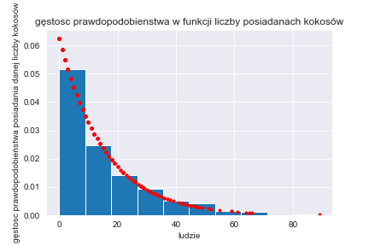

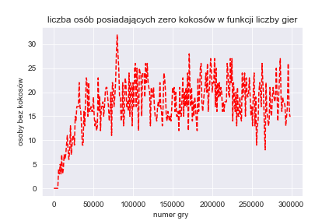

Figure 1. Example solution graphs

Additional materials on Boltzmann distribution:

* Ideologically the simplest illustration of Boltzman decomposition (according to

S.C. Zhang <https://arxiv.org/abs/1904.04669>)

* Physical model for the energy exchange between the particles of a gas

we obtain, when we divide (in each collision) the sum of the possessed

energy according to a random ratio

* numerous econo-physical models of wealth accumulation in the population:

attempts to reconstruct the power-law distributions "Statistical mechanics,

of money" <https://arxiv.org/abs/cond-mat/0001432>,   
<https://arxiv.org/abs/cond-mat/0004256>